A4010-Afr-Egy-Ushabti-New Kingdom-1600 BCE

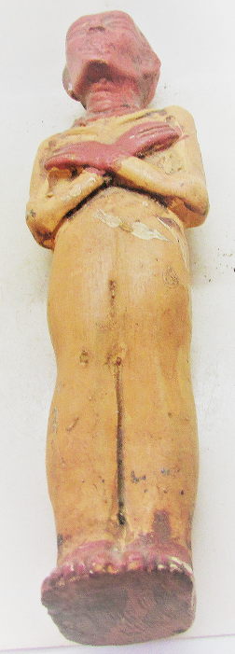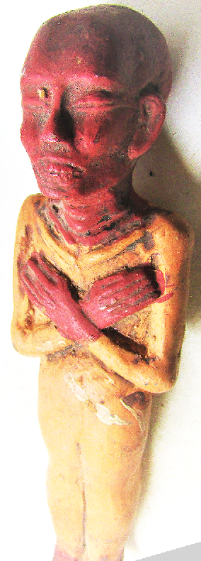

Case no.: 3

Accession Number:

Formal Label:

**Display Description:**

**LC Classification:**

Date or Time Horizon:

Geographical Area:

**Map:**

**GPS coordinates:**

Cultural Affiliation:

Media:

Dimensions:

Weight:

Condition:

Provenance:

**Discussion:**

**References:**